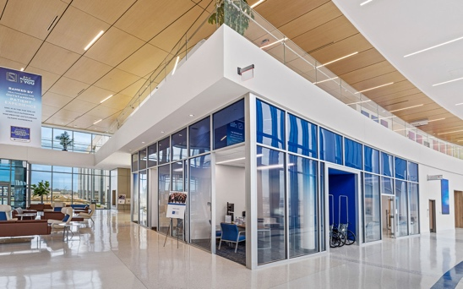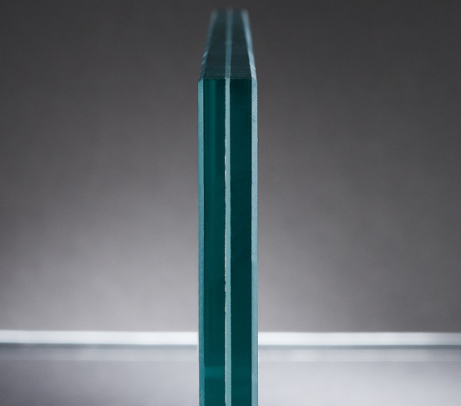
Versatile and customizable. Dreamwalls® Laminated Glass is a versatile product used in architectural and decorative applications. We offer a myriad of glass and interlayer combinations to create beautifully finished panels. Contact us today and get a partner committed to providing you the highest quality laminated glass and solving any problems quickly if and when they arise.
Satisfying customer expectations. Getting laminated glass that is done right with good edge quality can be challenging. The wrong vendor might disappear when there’s a problem, leaving you scrambling to figure out how to fix inaccurate products. You shouldn’t have to sacrifice your productivity, profits, or credibility to satisfy your customers. At Dreamwalls® we’re committed to getting it right and making you look good.

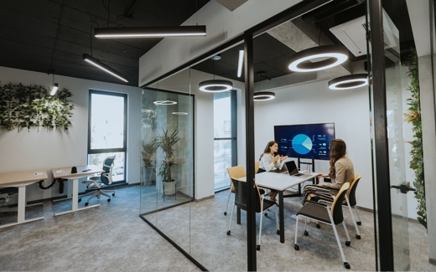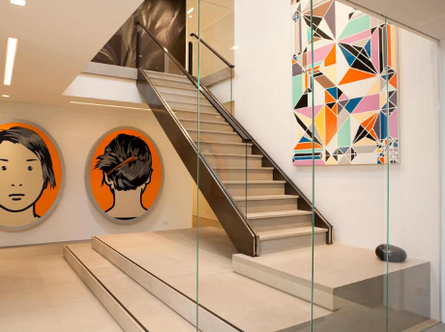
Quality and accuracy matter. At Dreamwalls® Tempered Glass, we get it. Time is money. You shouldn’t have to wrestle with a glass vendor to get tempered glass that is free from warpage and has all the notches and holes in the right place. At Dreamwalls® we meticulously temper and test the quality to ensure you’re getting tempered glass that thrills your customers and makes you look good.
What is tempered glass? Tempered or toughened glass is a type of safety glass processed by controlled thermal or chemical treatments to increase its strength compared with normal glass. Tempering puts the outer surfaces into compression and the interior into tension. Such stresses cause the glass, when broken, to crumble into small granular chunks instead of splintering into jagged shards as plate glass (a.k.a. annealed glass) does. The granular chunks are less likely to cause injury.
Gardner Glass Products are experienced fabricators of glass products with nationwide distribution. For further information, contact Dreamwalls® by Gardner Glass Products, Inc., North Wilkesboro, NC, (800) 334-7267, www.dreamwalls.com.
Specifier: This document is organized according to CSI MasterFormat and SectionFormat. Bold items require specifier selection. Convert bold to plain text, delete brackets, and removed specifier notes before publishing. This document is compatible with MASTERSPEC and SpecText editing tools.

SECTION 088126
INTERIOR GLASS GLAZING
- GENERAL
      - Section Includes
        - Laminated glass for interior applications.
        - Tempered glass for interior applications.
      - Related requirements
Specifier: Retain this optional Article and edit to provide cross reference to related work results in other sections. Section 088113 Decorative Glass Glazing and Section 101116 Markerboards are available from Dreamwalls®.
        - Division 08 Section "Glazing" for standard glass products.
        - Division 08 Section "Mirrors" for mirror glass.
        - Section 088113 Decorative Glass Glazing for back painted glass for interior applications.
        - Section 101116 Markerboards for customizable glass whiteboards and color markerboards.
      - reference standards
        - References, General: Versions of the following standards current as of the date of issue of the project or as required by applicable code apply to the Work of this Section.
Specifier: Retain this optional Article and edit to identify standards referenced elsewhere in the Section. Note that inclusion of a standard in this list does not require compliance with that standard; it must also be cited in the Section text.
        - American National Standards Institute (ANSI):
          - ANSI Z97.1 - American National Standard for Safety Glazing Materials Used in Buildings - Safety Performance Specifications and Methods of Test.
        - ASTM International (ASTM):
          - ASTM C1048 - Standard Specification for Heat-Strengthened and Fully Tempered Flat Glass.
          - ASTM C1172 - Standard Specification for Laminated Architectural Flat Glass.
        - Code of Federal Regulations (CFR):
          - 16 CFR 1201 - Safety Standard for Architectural Glazing Materials.
      - ADMINISTRATIVE REQUIREMENTS
Specifier: Retain one or both paragraphs below if complexity of work justifies requirements.
        - Preinstallation Meetings: Conduct pre-installation conference at the site to coordinate Work of this Section with related work.
        - Sequencing: Schedule installation of glass to follow adjacent work against which glass terminates. Schedule installation to follow nearby work whose execution may damage completed glass work.
      - ACTION SUBMITTALS
Specifier: Action submittals require responsive action by Architect.
        - Product Data: Submit manufacturer's printed data sheets or catalog pages illustrating glass products and accessories.
Specifier: Retain requirement below when Shop Drawings are required due to complexity of application; delete when Drawings adequately indicate layout of glass work.
        - Shop Drawings: Submit shop drawings prepared specifically for the Project illustrating layout, edge details, dimensions, and other data necessary for satisfactory installation that are not shown in the contract documents.
          - Indicate glass types with same designations used in this Section.
Specifier: Retain paragraph and subparagraph below for laminated glass if required.
        - Samples: In manufacturer’s standard size.
          - Verification samples for each laminated glass type.
      - INFORMATIONAL SUBMITTALS
Specifier: Informational submittals do not require responsive action by Architect.
        - Manufacturers' Instructions: Submit handling, storage, and installation instructions.
        - Warranty: Sample of proposed manufacturer warranty.
      - CLOSEOUT SUBMITTALS
        - Maintenance data for glass.
      - QUALITY ASSURANCE
Specifier: Retain paragraph when layout, patterns, or substrate present installation quality challenges best addressed by viewing of field mockups.
        - Mock-ups: Build mockup of each type of glass installation to demonstrate quality standards for installation.
          - Approved mockups may be incorporated in the completed Work.
      - DELIVERY, STORAGE, AND HANDLING
        - Delivery and Acceptance Requirements: Deliver materials to project site in original sealed packages, with manufacturer's label, and with storage and handling directions.
        - Storage and Handling Requirements: Store and handle materials in accordance with manufacturer's instructions.
          - Store in clean, dry location with adequate ventilation for air circulation.
          - Protect from damage from weather, excessive temperature, and construction operations
Specifier: Retain article below for laminated glass.
      - WARRANTY
        - Special Laminated Glass Warranty: On manufacturer’s standard form in which manufacturer agrees to replace laminated glass products which have defects in materials or workmanship that cause delamination resulting in materially obstructed vision through the laminated glass.
Specifier: 5-year warranties are available for laminated glass with PVB or EVA interlayers; 10-year warranties are available for laminated glass using SGP (Sentryglass Plus) interlayers. Retain both if both types of laminated glass are specified. Coordinate with Part 2.
          - Warranty Period: [5 years from date of Substantial Completion for laminated glass with PVB or EVA interlayers] [and] [10 years from date of Substantial Completion for laminated glass with SGP interlayers].
- PRODUCTS
      - MANUFACTURERS
        - Manufacturer: Project design is based upon products fabricated by Gardner Glass Products, Inc., North Wilkesboro, NC, (800)334-7267, www.dreamwalls.com.
          - Substitution Limitations: Provide basis of design product or comparable product approved by Architect [prior to bid] [in accordance with Division 01 requirements].
      - laminated glass
Specifier: Dreamwalls® Laminated Glass is fabricated using a vacuum bag convection process to allow for more flexibility and better control over the finished product.
        - Laminated Glass, General: ASTM C1172. Assembly of glass lites and interlayers laminated by manufacturer’s standard heat and pressure process. Use durable materials that will not bubble, discolor, or weaken after fabrication and installation.
Specifier: Copy paragraph below, re-edit, and re-paste as many times as required for each type of laminated glass. Create a unique identifier (e.g., LG#1, LG#2, etc.) for each type. Verify that Drawings identify and show location of each type. Contact Dreamwalls for assistance in editing.
        - Laminated Glass (LG#_)
          - Basis of Design Product: Gardner Glass Products, Inc., Dreamwalls® Laminated Glass.
Specifier: Retain Type II option below if safety glass is required.
          - Classification: [Type I Laminated Glass] [Type II Laminated Safety Glass meeting requirements of ANSI Z97.1 or 16 CFR 1201].
Specifier: Dreamwalls® Laminated Glass offers a myriad of glass and interlayer combinations. Visit the Dreamwalls® website or contract your Dreamwalls sales representative for additional information. For multiple layers of glass and interlayers, edit below as required. Dreamwalls® can provide laminated glass in total thicknesses up to 3 inches.
          - Construction: Two plies of [clear] [frosted] [white translucent] [mirror] <insert glass type>.
            - Thickness of Each Ply: [3 mm (1/8 inch)] [6 mm (1/4 inch)] <Insert thickness>.
Specifier: PVB (polyvinyl butyral) is the most commonly used interlayer and available in clear, pigmented, and patterned sheets. EVA (ethylene vinyl acetate) and SGP (Sentryglas Plus, an ionoplast interlayer) are also available. Contact Dreamwalls® for assistance in selecting an interlayer.
          - Interlayer: [PVB] [EVA] [SGP] <Insert interlayer material>.
            - Interlayer Thickness: [0.030 inch] [0.060 inch] [0.090 inch].
Specifier: Verify graphics are shown on Drawings or delete if no graphics.
            - Interlayer Graphics: As indicated on Drawings.
Specifier: Maximum size is 84 in x 140 in.
          - Size: <Insert Size Here>.
Specifier: Verify cutouts and penetrations are shown on Drawing or delete if none. Retain option if Shop Drawings are required in Action Submittals Article.
          - Cutout and Penetrations: As indicated on Drawings[ and approved shop drawings].
          - Edge: Manufacturer’s standard polished edge.
      - TEMPERED GLASS
        - Tempered Glass, General. ASTM C1048, Kind FT (fully tempered), Condition A (uncoated). Comply with ANSI Z97.1, and CPSC 16 CFR 1201.
Specifier: Copy paragraph below, re-edit, and re-paste as many times as required for each type of tempered glass. Create unique identifiers (e.g., TG#1, TG#2, etc.) for each type. Verify that Drawings identify and show location of each type. Contact Dreamwalls® for assistance in editing.
        - Tempered Glass (TG#_):
          - Basis of Design Product: Gardner Glass Products, Inc., Dreamwalls® Tempered Glass.
          - Thickness: [4mm (5/32 inch)] [5mm (3/16 inch)] [6mm (1/4 inch)] [8mm (5/16 inch)] [10mm (3/8 inch)] [12mm (1/2 inch)].
Specifier: Minimum size is 7 x 12 inches; maximum size is 67 x 144 inches. Larger custom sized may be available on a per project basis. Contact Dreamwalls® for assistance in editing.
          - Size: <Insert Size Here>.
Specifier: Verify cutouts and penetrations are shown on Drawing or delete if none. Retain option if Shop Drawings are required in Action Submittals Article.
          - Cutout and Penetrations: As indicated on Drawings[ and approved shop drawings].
          - Edge: Manufacturer’s standard polished edge.
- EXECUTION
      - INSTALLATION
Specifier: Retain option in paragraph below if Shop Drawings are required in Action Submittals Article.
        - General: Install glass units in accordance with manufacturer's recommendations[ and approved shop drawings].
      - cleaning
        - Wash exposed surfaces of glass as recommended by manufacturer not more than three days prior to scheduled inspection for Substantial Completion.
      - PROTECTION
        - Protect glass from damage resulting from construction activities.
        - Remove and replace broken or damaged glass.
END OF SECTION
Additional Specifiers Notes
Substitution Reviews: When reviewing substitution requests for other products for compliance with this specification, Dreamwalls® recommends particular attention to the following issues:
Performance characteristics.
Terms and conditions of available warranty.
Coordination with Drawings: Make sure you coordinate the following:
Location of each laminated and tempered glass unit, using designations from specification or schedule.
Size and shape of each unit, and sizes, shapes, and locations of cutouts and notches.
Method of mounting or support.

